Michael,   
  
          I have attached the most recent version of the Schema Request Form template for Word that I would use.  The password for the template is PESC2009 (dated version of the request form). When used properly, the CONTROL NUMBER in the upper right hand corner would format as USER INITIALs + CCYYMMDDHHMMSS of the date the document is created. In most cases, the request was copied from a previous request and the information changed and the CONTROL NUMBER was not changed. In these cases, I would use this template and unlock it and create a CONTROL NUMBER in the above format with the requestor's initials + the request date and a sequence number starting with '000001' and then copy the other information into the document.  In this way, it gave a consistent CONTROL NUMBER that I would also use as the document name to keep everything in sync.  I always kept the original request and prefixed with the CONTROL NUMBER and then would fill out the document with the additional information marked as completed as seen below. The '-completed' document would then be included in the package that I sent out as well as sent to Michael for publication when completed.   
  
  
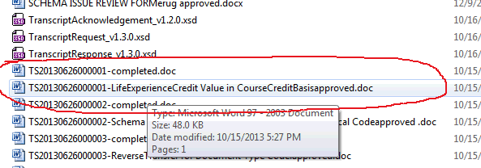  
  
  
  
  
  
  
Thanks for offering the assistance and feel free to contact me with any questions.   
________________  
Jeffrey A Funck  
Senior System DBA  
717.720.2779  
PHEAA